***3D-LIDAR ROBOTICS CLUB***

A device which scans the objects in its surroundings and makes a mapping of it on your display and guess what its small and cheap!!!

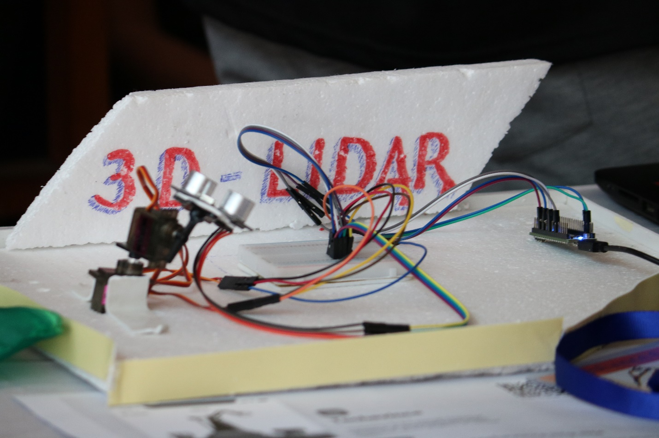

**Hardware Required**

1. Servo (2x1)
2. Arduino
3. Ultrasonic sensor(1x1)
4. Breadboard(1x1)

**Arduino**

Some great masters have developed the **Arduino board** to help us with our quest. This board will be the heart of the project, so building the project without it would be a harsh journey. We will be using Arduino UNO for this project but any board with at least 9 digital pins is good to go.

**Circuit Diagram**

**Code XD:-))**

**🡪For Arduino**

// Includes the Servo library

#include <Servo.h>.

// Defines Tirg and Echo pins of the Ultrasonic Sensor

const int trigPin = 10;//orange

const int echoPin = 11;//red white - vcc grey -gnd

// Variables for the duration and the distance

long duration;

int distance;

Servo myServo; // Creates a servo object for controlling the servo motor

void setup() {

pinMode(trigPin, OUTPUT); // Sets the trigPin as an Output

pinMode(echoPin, INPUT); // Sets the echoPin as an Input

pinMode(4,OUTPUT);//yellow

pinMode(12,OUTPUT);

Serial.begin(9600);

myServo.attach(9); // Defines on which pin is the servo motor attached on 9 purple

}

void loop() {

// rotates the servo motor from 15 to 165 degrees

for(int i=0;i<=180;i++){

myServo.write(i);

delay(30);

distance = calculateDistance();// Calls a function for calculating the distance measured by the Ultrasonic sensor for each degree

Serial.print(i); // Sends the current degree into the Serial Port

Serial.print(","); // Sends addition character right next to the previous value needed later in the Processing IDE for indexing

Serial.print(distance); // Sends the distance value into the Serial Port

Serial.print("."); // Sends addition character right next to the previous value needed later in the Processing IDE for indexing

}

// Repeats the previous lines from 165 to 15 degrees

for(int i=180;i>0;i--){

myServo.write(i);

delay(30);

distance = calculateDistance();

Serial.print(i);

Serial.print(",");

Serial.print(distance);

Serial.print(".");

}

}

// Function for calculating the distance measured by the Ultrasonic sensor

int calculateDistance(){

digitalWrite(trigPin, LOW);

delayMicroseconds(2);

// Sets the trigPin on HIGH state for 10 micro seconds

digitalWrite(trigPin, HIGH);

delayMicroseconds(10);

digitalWrite(trigPin, LOW);

duration = pulseIn(echoPin, HIGH); // Reads the echoPin, returns the sound wave travel time in microseconds

distance= duration*0.034/2;

if (distance < 40)

{

digitalWrite(4,HIGH);

digitalWrite(11,HIGH);

}

else

{

digitalWrite(4,LOW);

digitalWrite(11,LOW);

}

return distance;}

**🡪For Processing IDE**

**OUTPUT**

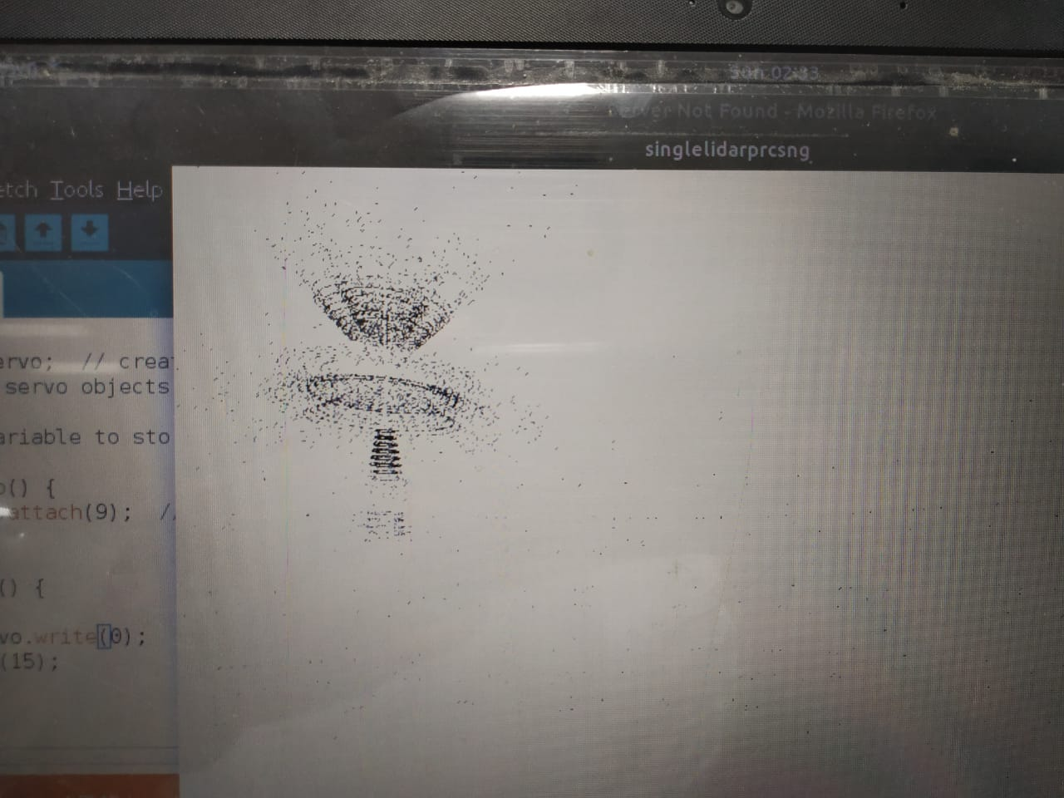

This is the mapping that we got of an object kept in front of LIDAR, this seems promising isn’t it.